Sentence Parsing

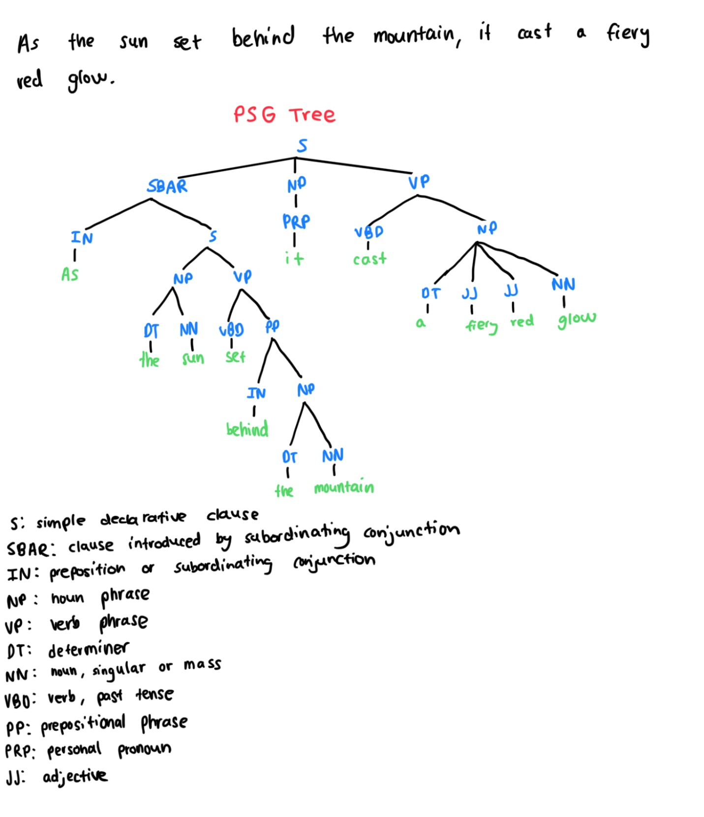

PSG or constituency parsing allows you to hierarchically organize phrases/constituents of a sentence. This method of parsing makes it easy to recognize parts of speech for each phrase as well as the levels of layering needed to understand the phrases role in the sentence. However, PSG parsing does not show relations necessary to fully comprehend the sentence such as the fact that the pronoun “it” refers to the sun not the mountain.

Dependency parsing is ideal to show the relations words in a sentence have with one another. Since it is visualized in a directed acyclic graph, you can follow the arrows to see which words are for example modifying subjects, among other roles. For this sentence it helps to see the dependencies across the two clauses. The downfall is that with a large sentence like this, dependency graphs can rapidly become more complex and harder to read.

Semantic role label parsing illustrates how each phrase assists the predicate or action in the sentence. It does this by breaking sentences into arguments and modifiers. This method of parsing is beneficial because if applicable, you can see numerous SRL levels for multiple predicates. In this sentence, there is a temporal modifier for when the “cast” occurred which can be seen in the second SRL parse. Although SRL parsing may not be as accurate when details about or referring to the agent are scattered throughout the sentence. For example, “sun” and “it” are referring to the same agent.